**Artificial Intelligence Based Price Negotiating**

**E-commerce Chat Bot System**

**A. Porselvi1, Pradeep Kumar Ramesh2****, A.V Hemakumar3, S.Manoj Kumar4**

1*Assistant Professor, Departmentof Computer Science, Panimalar Institute of Technology, Chennai, India*

2Student, Departmentof Computer Science, Panimalar Institute of Technology, Chennai, India

3*Student, Departmentof Computer Science, Panimalar Institute of Technology, Chennai, India*

*4Student, Departmentof Computer Science, Panimalar Institute of Technology, Chennai, India*

---------------------------------------------------------------------***---------------------------------------------------------------------

**Abstract -** *This paper describes an e-commerce website based AI chat bot. This chat bot can make it easier to interact and negotiate the price within the e-commerce website. The chat bot understands and converses with the user in simple language. This chat bot is integrated to an online market site. This website has a variety of products across the aisle. The chat bot helps you to purchase a product which is suitable for you at a negotiated price. This is especially helpful when you don’t have sufficient funds for the product you planning to purchase. Its function basically like a third party mediator between the buyer and the seller.*

***Key Words*:** **E-Commerce, Chat bot, Aisle, Mediator, AI, Merchant, Natural Language.**

**1. INTRODUCTION**

In the age of artificial intelligence and deep learning, Computer Science has had a lot of advancements in the past decade, and AI seems to definitely stands out distinguished among them. A chat bot is an artificial intelligence (AI) software that can simulate a natural language conversation (or chat) with a user via messaging applications, websites and mobile apps, or by telephone [1]. This project is aimed to implement a Chat Bot using tools that expose artificial intelligence methods such as natural language based automated negotiation that can give a flexible price instead of a fixed price for a product while shopping online, and can maximize the pay-offs of both buyers and sellers. It can be seen as an ideal and efficient mechanism for small scale online sellers with stiff competition. The business-to-consumer aspect of electronic commerce is the most visible business use of the World Wide Web. The primary goal of an e-commerce site is to sell goods and services online. This project deals with developing an AI based chat bot that negotiates the price with the different customers in an e-commerce market site. It also recommends the user with a catalogue of different products available for purchase in the online store through chat. Automated negotiation model can learn from past experience in negotiation, reason, and give a reasonable choice of price to the customer.

**2. RELATED WORK**

ELIZA[3] was one of the first chat bots and the brain behind it was Joseph Weizmann. Eliza's key method of operation involves the recognition of cue words or phrases in the input, and the output of corresponding pre-prepared or pre-programmed responses that can move the conversation forward in an apparently meaningful way[4]. Thus the key technique here—which characterises a program as a chat bot rather than as a serious natural language processing system—is the production of responses that are sufficiently vague and non-specific that they can be understood as "intelligent" in a wide range of conversational contexts. [1] More recent notable programs include A.L.I.C.E.[5], Jabberwacky[6] and D.U.D.E. While ELIZA and PARRY[7] were used exclusively to simulate typed conversation, many chatter bots now include functional features such as games and web searching abilities. Most of the existing virtual agents, also known as the chat bots, are mainly for entertainment and research purpose. Successful and Award winning chat bots like A.L.I.C.E and Clever Bot[8][9] focus on generic responses to entertain the end user. Some companies like IKEA, Lloyds Banking Group and Royal Bank of Scotland are using automated online assistants as first point of contact.

**3. CONCEPT DESCRIPTION**

E-commerce is an ever-evolving ecosystem with more than 10,75,000 merchants worldwide across several commodities. It’s primary unique selling proposition in the e-commerce ecosystem is that it is easy to operate and feature rich admin panel which is helpful for easily setting up an e-commerce store and effectively monitoring key store metrics to enhance purchase rates. However, an easy to use website doesn’t guarantee sales. E-commerce ventures always get subjected to a lot of competition from other sellers. Even after crossing the initial inflection point, e-commerce stores must consistently look to reduce shopping cart abandonment and increasing visitor to customer conversion for survival in the online market.

**4. E-COMMERCE DISCOUNT PROBLEM**

Personal experience made us believe that discount offerings are one of the most efficient methods of abandoned cart recovery. Primarily, because the way e-commerce ecosystem is consistently training consumers to expect discounts all the time. If we check your own email inbox. We will find several promotional emails from various merchants that you earlier used or subscribed to in the past. However, providing discounts consistently might not be enough for small businesses.. Also, trying to recover abandoned carts through targeted discount emails might not be that effective. Customers might already buy a product from a competitor website rather than waiting for a discount email to pop, this also expose your discount strategy, making you more predictable.

**5. PROPOSED SYSTEM**

The web application is developed using Visual Studio with Asp .Net with C# as a programming language. Proposed system is accessed by two entities namely, Admin and User. Admin need to login with their valid login credentials first in order to access the application. After successful login, admin can access all the modules and perform/manage each task accurately. Admin can perform task such as adding new product with its details and viewing added product details, viewing order details and user details. User can login using valid login credentials in order to access the system. If the user feels the product to be out of his budget or overpriced than other websites he can view products and chat with the AI bot for price negotiation for a particular product after negotiation, user can buy the product from the website or email will be sent to the customer with the negotiated price to make online payment for the designated item, this system reduces the use of online targeted ads which costs millions of dollars to the e-commerce merchants.

**6. COMPONENTS**

The two major components are the website and the chat bot. They are integrated seamlessly to provide a smooth user experience.

**6.1 WEBSITE**

The Project is loaded in Visual Studio 2019. We used Visual Studio for Design and coding of project. Created and maintained all databases into SQL Server 2019, in that we create tables, to write query for storing data.

**6.2 CHAT-BOT**

The chat bot utilises Rivescript, to fetch responses based on user input. Rivescript is a simple scripting language for giving intelligence to chat bots and other conversational entities. It's a plain text, line-based scripting language with goals of being simple to learn, quick to type, and easy to read and maintain. [11] The core implementation of the Rivescript[12] has the following major features:

1. Simple : Responses are coded in plain text file. No complicated syntax.

2. Powerful : It has a handful of rule that can be combined to build a fairly impressive chat bot.

3. Flexible : Rivescript follows the Unix philosophy: the core library is focused on rendering responses, while also leaving enough scope for extensibility by ways of custom modules and scripts.

4. Open Source : Rivescript is released in the MIT license, and are available on popular platforms such as Perl, Python, Javascript and even C#.[12]

We will utilise the C#. The entire Interpreter runs on the client browser, with the responses stored in simple text files, with the extension '.rive'. These responses are essentially the "brain" of the bot. The basic syntax of Rivescript follows the convention where "+" denotes a trigger i.e. a user query or input whereas '-' denotes the chatbot response. This is illustrated below:

Figure 1: Simple atomic trigger and response

**+ Hello**

**‐ Hello. I am Pradeep. How can I help you?**

This a simple atomic response. The interpreter matches user input with the stored triggers and determines the most suitable response to the user input. Rivescript also supports user and bot variables, wild cards, conversational redirects etc. Bot variables can be pre-programmed, whereas user variables can be set using parts from user query.[11] Rivescript also supports C# object macros. This allows us to program simple C# functionality.

**7. WORKING**

In order to implement the dynamic functionality, it comes with a robust back end system allowing merchants to easily setup products for which they want to negotiate with the customers through the chat bot. The real magic lies in the back end. This is where you can define different conditions for each product and setup replies that your chat bot will use based on the counter offers made by the customers. The merchants can define a minimal price to be accepted for a product. And can also define different conditions and messages for each scenario, the store owners have an option to effectually setup personalised chat bot that provides negotiations in a unique manner for each product – depending upon the defined conditions. Hence, merchants don’t experience in the hassle of interacting with each and every customer to negotiate discounts, while customers can get the best discounts based on their own offers.

**User: Hello**

**Bot: Hello there. How can I help you?**

**User: Price is high.**

**Bot: Can you share the item name**

**User: Black Stripe Shoe**

**Bot: What’s your offer?**

**User: 50Rs.**

**Bot: That’s too low, I can suggest you alternatives at that price range are you interested?**

**Figure 2:** Sample negotiation between user and the bot.

**A. Interaction between the User and the Chat bot.**

From the user's way of looking, the website has a chat box overlay in the side using which the user can chat with the bot. Any information the user requires, the user directly enters into the message window. The chat bots takes this input and matches it with the programmed responses, when the user submits the offer for the item the chat bot tries match the minimum asking price of the seller, if the price is not aligned to lowest mentioned price of the seller the chat bot gives a counter offer which the customer can decline or give a counter offer for the item. As this negotiation may happen back and forth, the chat bot can propose a final offer itself at any stage if it feels that the customer is nowhere close to the least price after multiple repeated attempts. At this moment, the customer has to accept or decline the deal to break the loop.

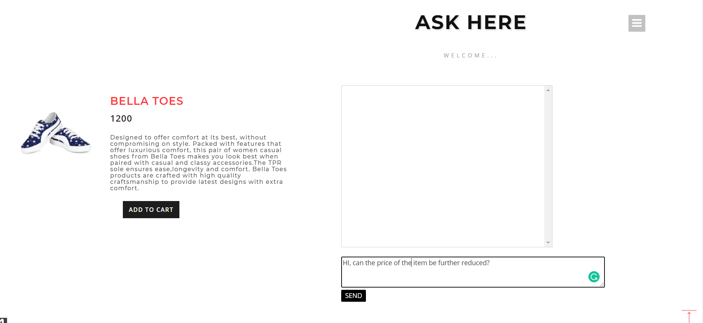

**Figure 3**: Chat-Bot Window Layout

**B. Interaction between Website and the Merchant**

The merchant or sellers in the back end can define different conditions for each product through admin login in the website and setup replies that your chat bot will use based on the counter offers received by the customers. The merchants can define a minimal price to be accepted from the maximum retail price of the product with a minimal profit margin in order to retain the customer and can also define different conditions and messages for each scenario, with such flexibility available right within the online store admin panel, merchants have an option to effectually setup personalized chat bot that provides negotiations in a unique manner for each product – depending upon the defined conditions.

Hence, merchants can retain his customers without losing them to the competition in the e-commerce platform, while customers can get the best discounts based on their own offers.

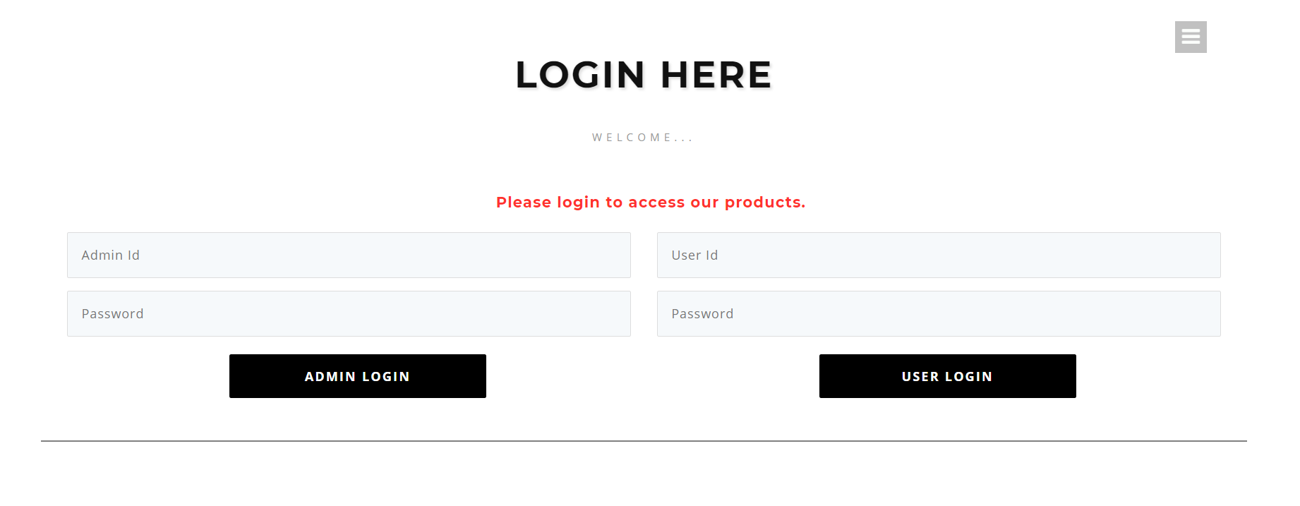**Figure 4**: Seller and Customers Login

|  |  |  |  |
| --- | --- | --- | --- |
| MERCHANT PRODUCT DIRECTORY | | | |
| **NAME** | **MRP** | **MINIMUM ACCEPTABLE PRICE** | **Auto Accept Price** |
| Black Loafers | 3000 | 2400 | 2500.00 |
| Red Shoes | 2000 | 1600 | 1700.00 |
| Blue Flips | 1500 | 1100 | 1200.00 |
| Pink Socks | 600 | 510 | 520.00 |

**Table -1:** Sample Merchant Product Directory

**8. CONCLUSIONS**

Thus we have implemented an AI based price negotiating chat bot which is a web application based on Asp .Net framework using C# programming language. The website based chat bot that attempts to improve user interaction with the E-Commerce website and reduce the abandonment of cart. The chat bot has a stored set of responses, but also takes dynamic user input into account and thus tends to provide relevant responses and suggests appropriate prices for the product. Since the product database is independent of the stored responses, newer products under the respective category can be easily added and removed and requires no modification of the stored chat bot responses needed.

**REFERENCES**

1. h[ttps://expertsystem.com/chat bot/](http://ijcsit.com/docs/Volume 6/vol6issue02/ijcsit20150602125.pdf)
2. Shabana Tadvi, Sultanat Rangari, and Ammar Rohe, L,2020. HR Based Interactive Chat bot (PowerBot).
3. [“](http://ijcsit.com/docs/Volume 6/vol6issue02/ijcsit20150602125.pdf)ELIZA - Wikipedia,the free encyclopedia.,” [Online]. Available:
4. [http://en.wikipedia.org/wiki/ELIZA. [Accessed March 2](http://ijcsit.com/docs/Volume 6/vol6issue02/ijcsit20150602125.pdf)021].
5. [J.Weizenbaum, “ELIZA - A Computer Program for the study of Natural](http://ijcsit.com/docs/Volume 6/vol6issue02/ijcsit20150602125.pdf)
6. [Spector, A. Z. 1989. Achieving application requirements. In Distributed Systems, S. Mullende](http://ijcsit.com/docs/Volume 6/vol6issue02/ijcsit20150602125.pdf)
7. [R. Carpenter, “jabberwacky - live chat bot,” [Online]. Available:](http://ijcsit.com/docs/Volume 6/vol6issue02/ijcsit20150602125.pdf)
8. []](http://ijcsit.com/docs/Volume 6/vol6issue02/ijcsit20150602125.pdf)“PARRY - Wikipedia,the free encyclopedia.,” [Online]. Available: http://en.wikipedia.org/wiki/PARRY.
9. [“](http://ijcsit.com/docs/Volume 6/vol6issue02/ijcsit20150602125.pdf)Cleverbot - Wikipedia,the free encyclopedia.,” [Online]. Available: [1]http://en.wikipedia.org/wiki/Cleverbot. [Accessed March 2021].
10. [“](http://ijcsit.com/docs/Volume 6/vol6issue02/ijcsit20150602125.pdf)Cleverbot.com,” [Online]. Available: http://www.cleverbot.com/. [Accessed March 2021].
11. http://ijcsit.com/docs/Volume%206/vol6issue02/ijcsit20150602125.pdf
12. An E-Commerce Website based Chatbot Siddharth Gupta#1, Deep Borkar#2, Chevelyn De Mello#3, Saurabh Patil#4